Akron Publishes New Collaborative Paper on Next-Generation DMSO-free cryopreservation
POSTED ON JULY 27, 2014
A collaborative study between Akron Biotechnology and groups at Stanford University, Harvard Medical School, Worcester Polytechnic Institute and Case Western Reserve University which brings together Akron’s expertise in cryopreservation media development together with next-generation approaches for cell preservation developed at Stanford and Harvard, has been published this week in the journalAdvanced Materials. The study, titled “Bio-Inspired Cryo-Ink Preserves Red Blood Cell Phenotype and Function During Nanoliter Vitrification“, is the culmination of extensive research and describes the use of novel, glycerol- and DMSO-free cryopreservation media developed at Akron for the rapid vitrification of red blood cells.
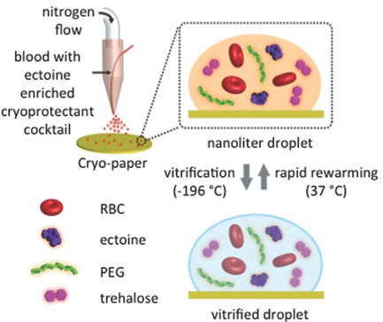
There is a significant need for novel approaches for the preservation of red blood cells that avoid the complications that arise with the use of traditional cryoprotectants such as DMSO and glycerol. The motivation behind this study was to develop such an approach – one that retains cell morphology and function and minimizes cryoinjury that occurs to the cells during the freezing process. As seen in the figure above, the approach is based on an ejector that dispenses nanoliter-sized droplets containing red blood cells and cryoprotectant, which are then rapidly vitrified. They key to the freezing process is the presence of a robust, DMSO-free cryoprotectant based on the naturally-occuring compound ectoin, developed at Akron Biotechnology. The compound was shown to retain cellular morphology analogous to fresh, non-cryopreserved red blood cells, together with intact functionality. Using this DMSO-free vitrification approach, a post-thaw cell viability of >82% was obtained, which was significantly higher than what was obtained when DMSO was used instead. Similarly, scanning electron microscopy observations indicated the membrane morphology to resemble that of unpreserved cells after vitrification with the ectoin-based cryoprotectant. Akron has long been developing novel cryopreservation media, and this paper is the result of Akron’s committment to researching and developing more tailored solutions for cell preservation that aim to target specific cell types. The ectoin-based cryoprotectant will soon be available as a commercial product – co keep watching this space for more information.

